North Elementary School
Tiger Times

February Events
2/1 World Read Aloud Day – Buddy Readers in Classrooms
2/4 FTE Week Starts
Reading for Education Fundraiser Starts
2/5 3rd Grade APTT 7:45 AM
2/6 Progress Report Day
2/8 Early Release Day – dismissal starts 11:30 AM
Jump Rope for Heart
PTO Meeting 1:00 PM
3rd Grade Family Fun Night 5:00PM-8:00PM (3rd grade fundraiser)
2/12 4th Grade APTT 7:45 AM
School Board Meeting 6:00 PM
2/18 Presidents Day – No School
2/19 5th Grade APTT 7:45 PM
2/21 Spring Book Fair Week
2/27 Spring Pictures
2/28 Family Night at NES:
Open House at the Book Fair 5:00PM-7:00PM

FSA Dates – Important!
4/2 FSA Writing (4th & 5^{th)}
4/3-4/4 FSA Reading (3rd)
5/1-5/2 FSA Reading (4th&5th)
5/6-5/7 FSA Math (3rd, 4th, 5th)
5/8-5/9 Science (5th)

F

3000 NW 10th Terrace, Okeechobee FL 34972
T: (863)462-5100
Website: nes.okee.k12.fl.us Facebook: @NESTigers
Character Trait of the Month: Tolerance
Dear NES Families,
In just the blink of an eye, we are almost half way through the 3rd grading period. Our students have worked very hard, and our assessment results are looking very good! According to the most recent iReady reports, our students are not only performing at a high level, but they are also making adequate learning gains! This is very important for us as making learning gains in reading and math was our main school improvement goal for the 2018-2019 schoolyear. We would like to thank all of our families for all the hard work and support. We could not do this without you!
Attendance Matters!
Attendance is important every day because students are more likely to succeed in academics when they attend school regularly. It is difficult for the teacher and the class to build their skills and make progress when a large number of students are frequently absent. Additionally, February 4-8 is FTE week! This is a time when the state will be looking at our class rolls and students’ attendance to determine the number of students who attend North Elementary School. In order to ensure that we receive funds for each child, it is more important than ever that your child is in attendance this week.

NES Crime Watch Club
We hope that you have seen the NES Safety Patrol student members in our hallways, helping out with keeping our campus safe. These students are also part of the NES Crime Watch Club, and our motto is “When you hear something, say something!”
Our Crime Watch Club will be conducting a school safety poster contest this month to identify ways that we can keep our school safe. All students are encouraged to participate!
Sierra Smith - a 3rd grade student and a Crime Watch Club member will be representing our club at the School Board meeting on February 12.
Thank you everyone for helping us with keeping our campus safe!

Out of Field Teachers - Addendum
FSA Dates, Continued
Please mark your calendars! FSA tests are required state assessments in grades 3-5, and we need all students at school on their test days. With the assessment window being very short this year, students will not have as many opportunities to make up these tests as they have had in past. Please avoid making doctor’s appointments on the testing days if possible!

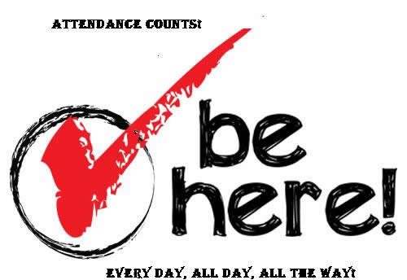

FSA

Mrs. Cassandra Holliday is teaching out of field in ESOL.
If you have any questions regarding Mrs. Holliday’s qualifications, please contact Dr. Tuuli Robinson at (863)462-5100 or robinsont@okee.k12.fl.us.
Okeechobee County School District NON-DISCRIMINATION NOTICE
The School District of Okeechobee County has adopted Board Policy 6.43, Unlawful Discrimination Prohibited. No person shall, on the basis of race, color, religion, gender, pregnancy, age, national or ethnic origin, genetic information, political beliefs, marital status, sexual orientation, gender identity, disability, if otherwise qualified, social and family background or on the basis of the use of a language other than English by Limited English Proficiency (LEP) students, be excluded from participation in, be denied the benefits of, or be subjected to discrimination under any education program or activity, or in any employment conditions or practices conducted by this School District, except as provided by law.
The School District of Okeechobee County shall comply with all federal and state laws which include the Title II of the Americans with Disabilities Act of 1990, as amended by the ADA Amendments Act of 2008 (ADAAA), Title IX, Section 504, Florida Education Equity Act, Age Discrimination in Employment Act (ADEA), Genetic Information Non-Discrimination Act of 2008 (GINA), and the Boy Scouts of America Equal Access Act.
Any employee, student, applicant for admissions, or applicant for employment who believes he/she has been discriminated against or has been harassed by another employee, student, or third party is encouraged to use the Equity Plan Grievance Procedure for filing complaints. Complaints may be filed with the principal or immediate supervisor, District Equity Coordinator/Director of Human Resources or the Superintendent.
Director of Human Resources
Title II, Title IX and the Florida Education Equity Act Complaints and
ADA/Section 504 Complaints
700 SW 2nd Avenue, Okeechobee, FL 34974
(863) 462-5000 Ext. 267

