North Elementary School
Tiger Times

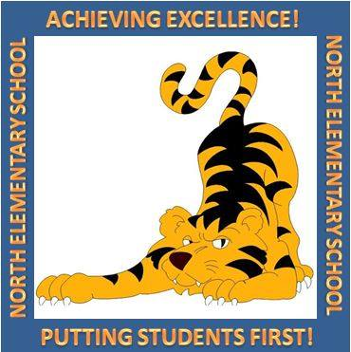

April Events

4/1 Kind Kids Club 3:00-4:00 PM
PTO Meeting 5:00 PM
4/2 4th and 5th Grade FSA Writing
4/3 3rd Grade FSA ELA Session 1
4/4 3rd Grade FSA ELA Session 2
Math Bowl Practice 3:15-4:15 PM
4/5 Mrs. Cotton’s Class visiting the Nursing Home
Science Olympiad practice 3:00-6:00 PM
4/8 Mothers’ Day Shoppe Week
Kind Kids Club 3:00-4:00 PM
4/9 Math Bowl Practice 3:15-4:15 PM
Student Code of Conduct Review at the County Office 4:00 PM
4/11 Gifted Riverwoods Field Trip
(1st and 2nd Grade)
4H Club Meets at NES
4/12 Mrs. Cotton’s Class visiting the Nursing Home
Science Olympiad practice
3:00-6:00 PM
4/15 Tennis Unit Starts (Grades 3-5)
Kind Kids Club 3:00-4:00 PM
4/16 2nd Grade Oceanographic
Institute Field Trip
Math Bowl at Osceola Middle School, 5:00-8:00 PM
Continued….

FSA Dates – Important!
4/2 FSA Writing (4th & 5^{th)}
4/3-4/4 FSA Reading (3rd)
5/1-5/2 FSA Reading (4th&5th)
5/6-5/7 FSA Math (3rd, 4th, 5th)
5/8-5/9 Science (5th)

F

3000 NW 10th Terrace, Okeechobee FL 34972
T: (863)462-5100
Website: nes.okee.k12.fl.us Facebook: @NESTigers
Character Trait of the Month: Commitment

Dear NES Families,

The last grading period will be a busy time full of many activities. Our students in grades 3-5 will be participating in their Florida Standards Assessments (FSA) starting this week. We have worked hard this year, and we are ready to rock the FSA!

APTT Dates

To avoid events at school during the high stakes assessments, we had to change some of our APTT dates. The final APTT dates for this year are:
KG - May 29 (prior to the end of the year program)
1st – May 10
2nd – May 21 (no change)
3rd – May 14 (no change)
4th – May 24 (prior to the awards)
5th – May 28 (no change)
We hope to see everyone at our last APTT meetings to celebrate our students’ success with us!

Clubs on Campus

Several clubs are meeting on our campus. Kind Kids Club for students in grades 2-4 meets every Monday from 3-4 PM. The focus on this club is on promoting kindness among our students. We currently have over 50 students participating in our Kind Kids Club. We hope to extend this club to other grade levels!
Our Science Olympiad participants are meeting on selected Fridays to prepare for the culminating event in Orlando on April 20 where students from all over Florida compete as a team against other schools in 23 different events that range the spectrum of science subjects. We wish the best of luck to our team!

April is School Library Month!

School Library Month is the American Association of School Librarians' celebration of school librarians and their programs. Every April school librarians are encouraged to host activities to help their school and local community celebrate the essential role that strong school library programs play in transforming learning. This year’s theme is Everyone Belongs @ Your School Library. We would like to recognize Ms. Savannah Catron for all the wonderful things that she is doing in our Media Center for our students!

Title I Parent Surveys are Sent Home This Week
Please help us by completing the Title I Parent Survey this month! We receive free poster printer paper for 175 completed surveys, and additional ink for the printer for 225 or more completed surveys. Please help our school!

Order Your NES Yearbook April 1-April 5

April Events, Continued
4/17 Progress Report Day
2nd Grade Oceanographic
Institute Field Trip (2)
KG Roundup Letters Go Home
Today!
4/18 Early Release Day
NES Spelling Bee 8:30 AM
(Open for parents)
KG Dairy Visit
4/19 Good Friday – No School
4/20 Science Olympiad in Orlando
4/22 NES Tropicana Speech
Contest (Closed for public)
Kind Kids Club 3:00-4:00 PM
4/23 OHS Senior Grad Walk
4/25 NES Parent Night 5:00 PM
4/26 College T-Shirt Day
District Spelling Bee 9:30 AM
at OFC
4th and 5th Grade FSA PEP
Rallies
4/29 Kind Kids Club 3:00-4:00 PM 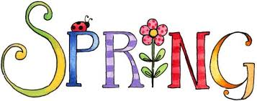

FSA
N
NES 2018-19 yearbooks will be on sale from Monday, April 1-Friday, April 5. Soft cover books cost $25, and hard cover books $35. It is the easiest to place your order online at northelem.picaboo.com. Thank you for supporting our school!
Okeechobee County School District NON-DISCRIMINATION NOTICE
The School District of Okeechobee County has adopted Board Policy 6.43, Unlawful Discrimination Prohibited. No person shall, on the basis of race, color, religion, gender, pregnancy, age, national or ethnic origin, genetic information, political beliefs, marital status, sexual orientation, gender identity, disability, if otherwise qualified, social and family background or on the basis of the use of a language other than English by Limited English Proficiency (LEP) students, be excluded from participation in, be denied the benefits of, or be subjected to discrimination under any education program or activity, or in any employment conditions or practices conducted by this School District, except as provided by law.
The School District of Okeechobee County shall comply with all federal and state laws which include the Title II of the Americans with Disabilities Act of 1990, as amended by the ADA Amendments Act of 2008 (ADAAA), Title IX, Section 504, Florida Education Equity Act, Age Discrimination in Employment Act (ADEA), Genetic Information Non-Discrimination Act of 2008 (GINA), and the Boy Scouts of America Equal Access Act.
Any employee, student, applicant for admissions, or applicant for employment who believes he/she has been discriminated against or has been harassed by another employee, student, or third party is encouraged to use the Equity Plan Grievance Procedure for filing complaints. Complaints may be filed with the principal or immediate supervisor, District Equity Coordinator/Director of Human Resources or the Superintendent.
Director of Human Resources
Title II, Title IX and the Florida Education Equity Act Complaints and
ADA/Section 504 Complaints
700 SW 2nd Avenue, Okeechobee, FL 34974
(863) 462-5000 Ext. 267

