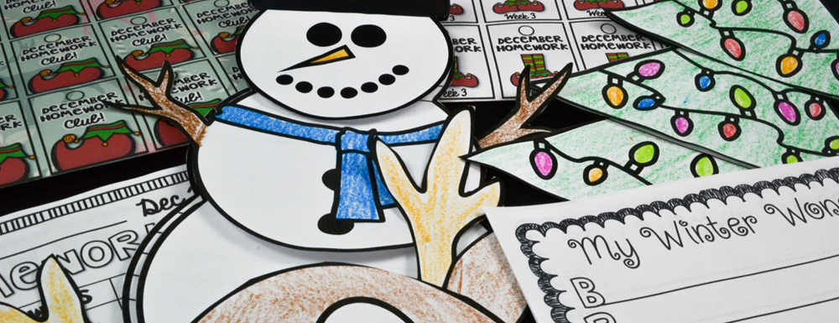
North Elementary School
Weekly Memo for Parents
December 9, 2019

Welcome to another wonderful week!

NES will be participating in the Okeechobee Main Street Christmas Parade on Saturday, December 14. Students are invited to walk with teachers and staff members to represent NES. Please be on the lookout for the permission slip that will be sent home this week!

Students have an opportunity to participate in the PBIS raffle for the next two weeks. Students can find raffle boxes in the cafeteria, and drop in their Tiger Paws for a chance to win!

Every Sunday
Bedtime Story with Principal Robinson 7:30 PM on NES Facebook Page (www.facebook.com/NESTigers).
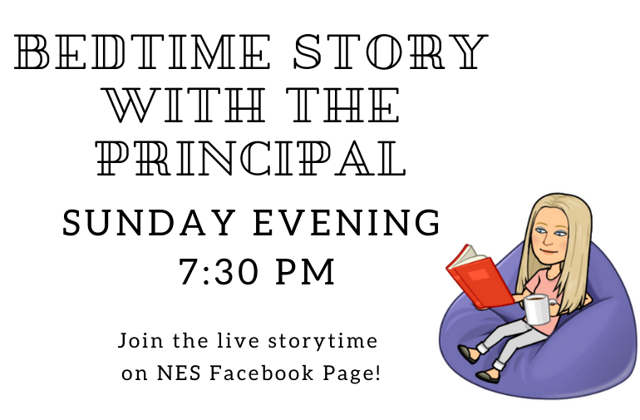

Monday, December 9
- Fall Fundraiser items are scheduled to arrive this afternoon! If we have them ready for pick up prior to the end of the school day, we will make an all call. Thank you for your patience!

Tuesday, December 10
- Fall fundraiser pickup starts
- NES Holiday Shop starts today! Families can visit from 7:45 AM to 8:10 AM. Students will be invited to visit according to the schedule that is shared with teachers. There will be individual shopping opportunities as well. We are also looking for volunteers to help us run the shop! Please contact Mrs. Shirley if you are an approved volunteer and would like to help us out!!!
- OHS Drama Club Play (grades 2-5)
- After school tutoring 3:15-4:30 PM (pickup is at 4:30 from the parent pickup circle)
  - Students who received and returned the permission slips should stay (4th grade ELA, 5th grade Math and Science)
- Band Practice 3:15 - 5:15 PM
- School Board Meeting 6 PM. NES will be recognized for participating in the Food for Families food drive. Mrs. Tracy Phillips will be recognized for her work with the Science Instructional Maps over the summer.

Thursday, December 12
- 5th grade DARE graduation
- Dental sealants program continues this week on Thursdays and Fridays. Students in grades K, 2, and 3 who turned in an approved parental consent form will participate.
- After school tutoring 3:15-4:30 PM (pickup at 4:30 from the parent pickup circle)
  - Students who received and returned the permission slips should stay (4th grade Math, 5th grade ELA)
- Band Practice 3:15 - 5:15 PM

Friday, December 13
- County Track and Field event at OHS 9:00 AM
- NES Chorus 3:15 to 4:15 (pickup at 4:15 from the parent pickup circle)
- Parent Night Out at NES 6:00-8:30 PM (this is a 2nd grade fundraiser - open to all NES students).

Saturday, December 14
- City Christmas Parade - NES students are invited to walk in the parade. Permission slip is required!

Upcoming Dates
- December 2-20 - iReady Diagnostic Assessment Window
- December 19 - Jump Rope for Heart Assembly
- December 19 - NES Holiday Concert 6:30 PM
- December 20 - KG Christmas Program
- December 20 - Early Release Day; End of 2nd 9 Weeks

- Math facts practice is available at https://www.reflexmath.com/
- Additional iReady lessons can be accessed at https://login.i-ready.com/
- Tutorials on Florida Standards are available at http://www.floridastudents.org/
- Video tutorials and practice for core subject areas on each grade level are available at https://www.khanacademy.org/
- And of course, please do not forget to read at least 20 minutes each day!!!

Other Important Information

- Lunch and breakfast are free to all of our students! We encourage all students to take advantage of this wonderful program and start their day with a healthy breakfast!
- Reports concerning unsafe, potentially harmful, dangerous, violent, or criminal activities, or the threat of these activities, can be made to appropriate public safety agencies and school officials using the following link: https://getfortifyfl.com/Tip.html

Let’s make this a great week!
Go Tigers!
Dr. Tuuli Robinson
Principal of North Elementary School
Phone: (863) 462-5100
E-mail: robinsont@okee.k12.fl.us

