North Elementary School
Tiger Times

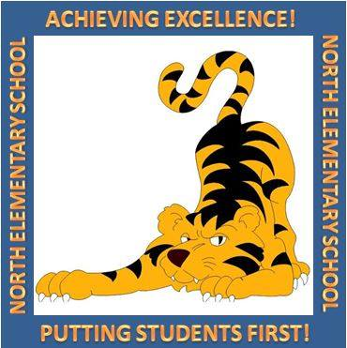

March Events
3/4 National School Breakfast Week Starts Today
3/5 Fruit Smoothies for Breakfast!
3/5 Math Bowl Practice 3:15-4:15
School Board Meeting 6:00
3/7 Chocolate Fountain Party for Fall Fundraiser
3/8 Last day of the grading period for the 3rd 9 weeks
All Stars vs. Faculty Kick Ball
Water Safety presentation in KG
1st Grade to Wooden Jungle
2nd Grade to Wooden Jungle
3rd Grade to Kennedy Space Center
3/11 Spring Break Week – No School
3/18 Teacher Work Day – No School
SAC Meeting 5:00 (Rescheduled from 3/21)
3/19 Minute to Win It AR Reward
Math Bowl Practice 3:15-4:15
3/25 3rd Grade Awards 8:30 AM
3/26 Report Card Day
4th Awards 8:30 AM
5th Grade Awards 9:15 AM
Straight A’s Luncheon at Golden Corral
Math Bowl Practice 3:15-4:15
3/27 Spring Pictures
Dress for Success Day
3/28 LAST DAY OF TUTORING
3/29 College T-Shirt Day

FSA Dates – Important!
4/2 FSA Writing (4th & 5^{th)}
4/3-4/4 FSA Reading (3rd)
5/1-5/2 FSA Reading (4th&5th)
5/6-5/7 FSA Math (3rd, 4th, 5th)
5/8-5/9 Science (5th)

F

3000 NW 10th Terrace, Okeechobee FL 34972
T: (863)462-5100
Website: nes.okee.k12.fl.us Facebook: @NESTigers
Character Trait of the Month: Perseverance
Dear NES Families,
As we are wrapping up the third grading period, I would like to take a moment to thank all of our students, staff, and families for all the hard work with our students both at school as well as at home! We are pleased to announce that our students have made excellent gains on their iReady assessments, and more and more students are already demonstrating grade level proficiency on their assessments.
In 3rd grade reading, 73% of students demonstrated proficiency on their 2nd diagnostic assessment (6% increase from Fall). In 4th grade reading, 61% of students demonstrated proficiency on their 2nd diagnostic assessment (4% increase from Fall). In 5th grade reading, 55% of students demonstrated proficiency on their 2nd diagnostic assessment (7% increase from Fall).
In 3rd grade math, 77% of students demonstrated proficiency on their 2nd diagnostic assessment (2% increase from Fall). In 4th grade math, 77% of students demonstrated proficiency on their 2nd diagnostic assessment (4% increase from Fall). And finally, in 5th grade math, 67% of students demonstrated proficiency on their 2nd diagnostic assessment (6% increase from Fall).
While kindergarten -2nd grade students do not participate in state assessments, we would like to recognize their great work and success on the assessments as well! We would not see the progress that we currently see in 3-5 grades if it was not for the solid foundation laid in primary grade levels where students acquire the foundational skills.
Way to go NES!
School Safety
In February, NES Crime Watch Club conducted a Safe Schools poster contest. Many students participated in the contest and turned in posters that address ways to be safe at school – including hallways safety, playground safety, etc. All posters are displayed in our front hallway. Please take a moment to look at our students’ work when visiting our campus!
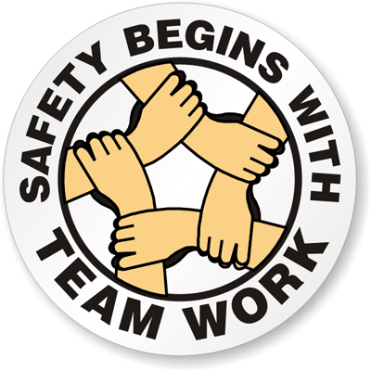
Additionally, to comply with the safety regulations from the state and to ensure that our students and staff are well versed when it comes to school safety, NES will be conducting monthly lock-down drills. These are routine drills just like fire drills. All visitors on the campus are expected to follow our lock-down procedures.
Thank you everyone for helping us with keeping our campus safe!

Order Your NES Yearbook Advertisement Now!
SAC Meeting- Change of Date!
Please be advised that our SAC Meeting has been rescheduled from Thursday, March 21 to Monday, March 18.The meeting will take place in our Media Center at 5 PM. Everyone is invited!
School Chaperones
With many field trips coming up prior to the end of the school year, we would like to remind everyone that only pre-arranged volunteers can chaperone on our filed trips. Grade level teachers will notify parents of any needs for field trip chaperones. All chaperones must be cleared by the district through the OCSB Volunteer Porgram that includes a formal background check. If you would like to volunteer at NES, please complete a Volunteer Application package (available at our front office).

FSA

You can still place orders for your very own page in our 2018-19 yearbook! The deadline has been extended to March 8, 2019. There are different size options available, including full page, half page, and quarter of a page. You may send the yearbook order form with your child, or you can email it to Chelsea Fraser at Chelsea.Fraser@okee.k12.fl.us
No physical photographs will be accepted. Please make checks out to NES.
Okeechobee County School District NON-DISCRIMINATION NOTICE
The School District of Okeechobee County has adopted Board Policy 6.43, Unlawful Discrimination Prohibited. No person shall, on the basis of race, color, religion, gender, pregnancy, age, national or ethnic origin, genetic information, political beliefs, marital status, sexual orientation, gender identity, disability, if otherwise qualified, social and family background or on the basis of the use of a language other than English by Limited English Proficiency (LEP) students, be excluded from participation in, be denied the benefits of, or be subjected to discrimination under any education program or activity, or in any employment conditions or practices conducted by this School District, except as provided by law.
The School District of Okeechobee County shall comply with all federal and state laws which include the Title II of the Americans with Disabilities Act of 1990, as amended by the ADA Amendments Act of 2008 (ADAAA), Title IX, Section 504, Florida Education Equity Act, Age Discrimination in Employment Act (ADEA), Genetic Information Non-Discrimination Act of 2008 (GINA), and the Boy Scouts of America Equal Access Act.
Any employee, student, applicant for admissions, or applicant for employment who believes he/she has been discriminated against or has been harassed by another employee, student, or third party is encouraged to use the Equity Plan Grievance Procedure for filing complaints. Complaints may be filed with the principal or immediate supervisor, District Equity Coordinator/Director of Human Resources or the Superintendent.
Director of Human Resources
Title II, Title IX and the Florida Education Equity Act Complaints and
ADA/Section 504 Complaints
700 SW 2nd Avenue, Okeechobee, FL 34974
(863) 462-5000 Ext. 267

